Referencing digital journal articles using
Word on MACs

For digital versions of journal articles using APA referencing, a DOI is required (or if unavailable, a URL - website address).

Unfortunately, Word on Macs does not have a Bibliography field for a DOI.

So, we need to do a “work around” which entails a few extra steps.
Suggested approach:

- In your Word document, click on References, Citations, + (see below)

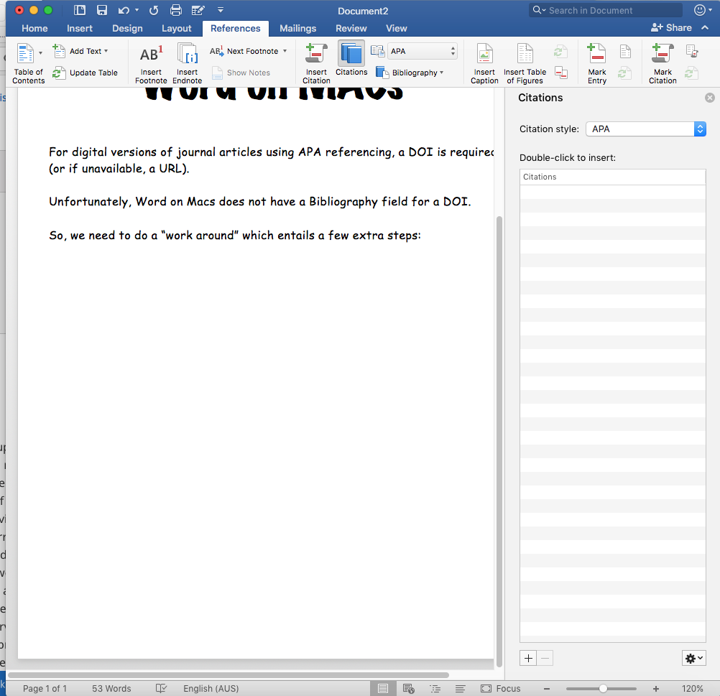

- It is helpful to have a split screen with the article on one side and your Word Doc on the other. Following the above directions will give you access to the Bibliography Fields you need to fill in.

- Let’s do the DOI/URL “work around” first. Select ‘Web Site’ as your Type of Source. In the URL field, copy and paste the DOI details supplied (or if no DOI, the URL - website address)
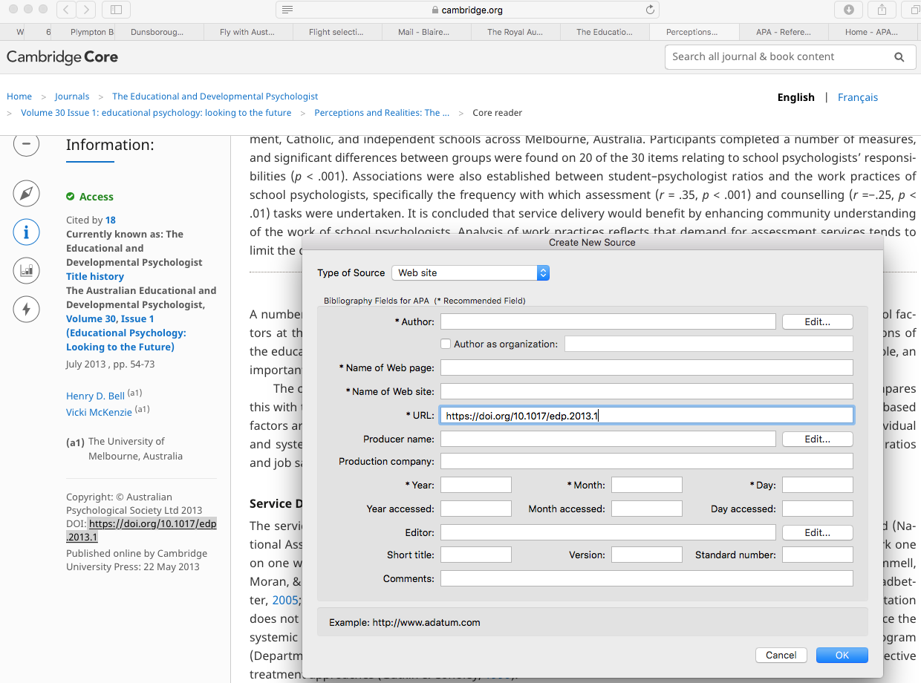

- Now, back to the normal process. Select ‘Article in a Journal’ as your Type of Source. (NB. The DOI/URL details will disappear - DON’T WORRY - they are stored safely in a hidden location ready to appear in your Bibliography!) Complete the rest of the necessary fields. TIP: If there is more than one author, click on the edit button on the right of the author field and fill in the author details exactly as they appear on the journal article, then click on the + to add the next author name.
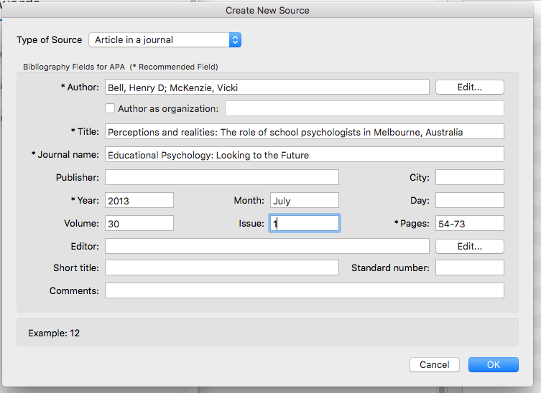

- Finally, when you are ready to supply your Bibliography at the end of your work (it should have its own page), click on References, Bibliography.
Your reference(s) will be supplied as follows:

Bibliography
Bell, H. D., & McKenzie, V. (2013, July). Perceptions and realities: The role of school psychologists in Melbourne, Australia. Retrieved from https://doi.org/10.1017/edp.2013.1

- Finally, if there was a DOI, you must delete the words “Retrieved from” that will automatically appear. Now, your reference below is accurate!

Bibliography
Bell, H. D., & McKenzie, V. (2013, July). Perceptions and realities: The role of school psychologists in Melbourne, Australia. https://doi.org/10.1017/edp.2013.1

