PREVENTING PLAGIARISM CHECKLIST
Make sure you have:
- Referenced any ideas you have paraphrased from someone else’s work.
Paraphrasing is where you use another person’s ideas but write it in your own words. Years 10-12 should include an in-text citation so that the reader can refer to the original sources.

- Used direct quotations sparingly.
A direct quote is where a someone’s exact words are utilised in your work. Quotes should be brief and used only to support the points you are making. They should always be put inside quotation marks.

- Used and referenced images/visual elements appropriately.
It is best to use images that have either been created by you or obtained from sources like Pixabay and are copyright free. It is important that these are referenced appropriately with an in-text citation beneath the image.

- Included a bibliography of all the sources you have used.
Make sure that you have followed the APA format that Kennedy Baptist College expects.

- NOT copied and pasted information from another source (unless it is used as a direct quote and you have referenced it).
If you copy and paste from research and fail to reference it appropriately, then you are guilty of plagiarism. It doesn’t matter if this was intentional or not. Plagiarism is treated very seriously at Kennedy Baptist College and penalties will apply.

- NOT submitted another student’s work as your own.
Students often collaborate and work together on schoolwork. However, assessments that only have your name, must be your own work.
Don’t let anyone else submit your work as their own either.

- NOT copied a previously submitted assignment.

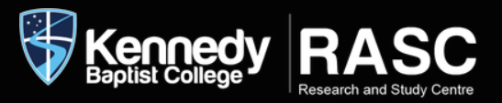
For help go to: http://kennedyrasc.weebly.com/plagiarism.html or ask at the RASC

